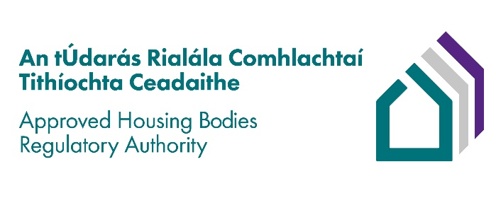

Application Form – Senior Regulatory Manager – Grade 7 (Administrative Officer)

PERSONAL DETAILS
Surname: | First name(s):
Address: | Phone:  Email:
Are you an Irish/EEA Citizen? Yes/No  If no, are you eligible to work in Ireland? | How did you hear about this post?

Notes for Applicants:
- All sections of the application form must be completed.
- Applications should be typed and submitted in PDF format, to www.lexconsultancy.ie/clients/AHBRA
- Candidates must provide:
  - a covering letter outlining their suitability for the post
  - a completed Approved Housing Bodies Regulatory Authority application form
- Incomplete applications will not be considered for shortlisting.
- Applicants will be short-listed based on the information supplied.
- Applications will not be accepted under any circumstances after the closing date.
- Canvassing by or on behalf of the applicant will automatically disqualify.

Closing date for receipt of applications – Monday, 27th March 2023 at 12.00

- APPLICANT DECLARATION AND CONSENT
All information provided in this application is, to the best of my knowledge true and correct.

I understand that should any of the particulars furnished in this application be found to be false or inaccurate, action may be taken to withdraw any offer of employment.

I confirm that I have read the Approved Housing Bodies Regulatory Authority’s (AHBRA) Privacy Notice and understand how my data will be processed by the AHBRA for the purposes of this job application.

Name: | Date:

- EMPLOYMENT - Please detail below, in date order, starting with your current role, full particulars of all employment between the date of leaving college and the present date. No period between those dates should be unaccounted for. Please add new records as required.

EMPLOYER  (Name & address) | POSITION including Grade Held  Brief description of duties and achievements | DATES  FROM / TO | REASON FOR LEAVING
EMPLOYER  (Name & address) | POSITION including Grade Held  Brief description of duties and achievements | DATES  FROM / TO | REASON FOR LEAVING
EMPLOYER  (Name & address) | POSITION including Grade Held  Brief description of duties and achievements | DATES  FROM / TO | REASON FOR LEAVING
Please attach additional pages if required.

- EDUCATION

Qualification including Grade of Result Obtained | Academic Institution/ College | Course (including Level in the National Framework of Qualifications) | Year

- PROFESSIONAL MEMBERSHIPS/ASSOCIATIONS

- REFEREES - Please provide details of two Referees who are known to you, one must be your current or a recent employer.
(Referees will not be contacted unless an offer of employment has been made)
Referee No. 1 | Referee No. 2
Name: | Name:
Address: | Address:
Contact Number: | Contact Number:
Email address: | Email address:
Relationship to you: | Relationship to you:

COMPETENCY ASSESSMENT

In the following sections, you are asked to describe some of your personal achievements to date that demonstrate certain skills and abilities which have been identified as necessary for the position of Senior Regulatory Leader – Grade 7 (Administrative Officer).

In no more than 200 words in the space provided under each competency briefly set out what you consider to be a good example of how you demonstrated your ability in each of these areas. Your example should include a brief description of the nature of the task/problem detailing how you demonstrated the skill required and the outcome.

Please try not to reuse the same example for more than one competency.

Interpersonal & Communication Skills

Management & Delivery of Results

Judgement, Analysis & Decision Making

Specialist Knowledge

ADDITIONAL INFORMATION
Please provide any additional information that you deem relevant to your application

